Agent-based simulation of pathways towards neighbourhood-level building retrofits
Ardak Akhatova, Technische Universität Wien, Karlsplatz 13, 1040 Vienna, Austria
+43 1 58801 370336, akhatova@eeg.tuwien.ac.at
Lukas Kranzl, Technische Universität Wien, Karlsplatz 13, 1040 Vienna, Austria
+43 1 58801 370351, kranzl@eeg.tuwien.ac.at

Overview
Energy-efficient retrofitting of existing buildings and neighborhoods, including measures such as thermal insulation of a building envelope (i.e., walls, roof, floor) and installation of energy-efficient windows, is essential for space heat demand reduction and subsequent carbon emissions cut. However, buildings are not being retrofitted at a sufficient speed and depth, as only 1% of the total building stock in Europe gets renovated annually [1]. Especially in the residential sector, it is challenging to design policies that encourage owners’ decisions to renovate. The state-of-the-art literature and empirical studies show that both monetary and non-monetary barriers exist towards greater uptake of energy efficiency measures among owner-occupiers. While lack of capital and aversion to delayed gains have been known to be important barriers [2], recent studies emphasize high non-monetary transaction costs (e.g. cost of information search, contract negotiations, etc.) as strong barriers to retrofit uptake [3–5]. This study presents an explorative simulation of neighbourhood retrofit (i.e., insulation) adoption that accounts for these economic and non-economic barriers as well as other important determinants of insulation (e.g., building age or availability of subsidy). The neighborhood level is chosen as it is an appropriate level for energy concept planning and policy interventions [6,7]. The effects of possible policy strategies and social influence on the uptake levels will be simulated and discussed. The unique contribution of this work is in bringing together the findings from social scientific studies into a quantitative model as a first step in developing a multi-disciplinary policy support tool.

Methods
An agent-based model (ABM) is a computer simulation of an artificial world populated by agents – discrete decision-making entities (e.g., individuals, households, firms). Its advantage over traditional equation-based modelling approaches in energy systems analysis (i.e., system dynamics, optimisation models, computable general equilibrium models) is its ability to incorporate heterogeneity and adaptivity of the agents [8], which steps outside the microeconomic assumption of the representative economic agent. Moreover, it can show how macro-level patterns emerge from micro-level decisions of agents [9]. The application of agent-based modelling (ABM) in policy and planning of energy transition is particularly valuable, as it can inform decision-making and addresses the issues of interdisciplinarity and participation [10]. One of the most established approaches in ABM is the technology or innovation diffusion ABMs, where agents decide to adopt or not adopt (i.e., to invest or not invest in a certain technology or to perform a certain energy-related action) based on specific rules or algorithms [11].
The rules for an agent in the ABM adopting or not adopting one of the insulation measures of various thicknesses (10 cm, 15 cm, 20 cm) are defined in this work. These rules are based on the agents’ heterogeneous parameters (attitude towards renovation, owned building’s age and renovation status, disposable income) and the external factors, such as availability of a subsidy or one-stop shops, and experience and skills of retrofit providers. In a timestep representing 6 months, each agent goes through a multi-stage decision process, which incorporates the effect of the barriers identified from the literature and empirical findings. The adopters’ new attitude will change after the implementation and the adopters “disseminate” their feedback for retrofit by influencing other agents’ attitude via an opinion dynamics model [13]. After several timesteps (e.g., 6 timesteps = 3 years), the simulation ends and the number of adopters and non-adopters, the type of adopted measures, costs of renovation, local emission savings due to energy demand reduction in this simulated scenario are known. Figure 1 depicts the flowchart of the simulation.

Results
The results will show several scenarios of neighbourhood renovation for a generic residential neighbourhood in the Netherlands with building archetypes from Tabula Episcope [12]. The scenarios include (but not limited to) such policy approaches as implementing one-stop-shops to reduce the transaction costs and organizing common purchase of retrofitting services. The sensitivity analyses with regard to the key variables of the model, such as gas and electricity prices, agent’s attitude towards renovation, will be presented.
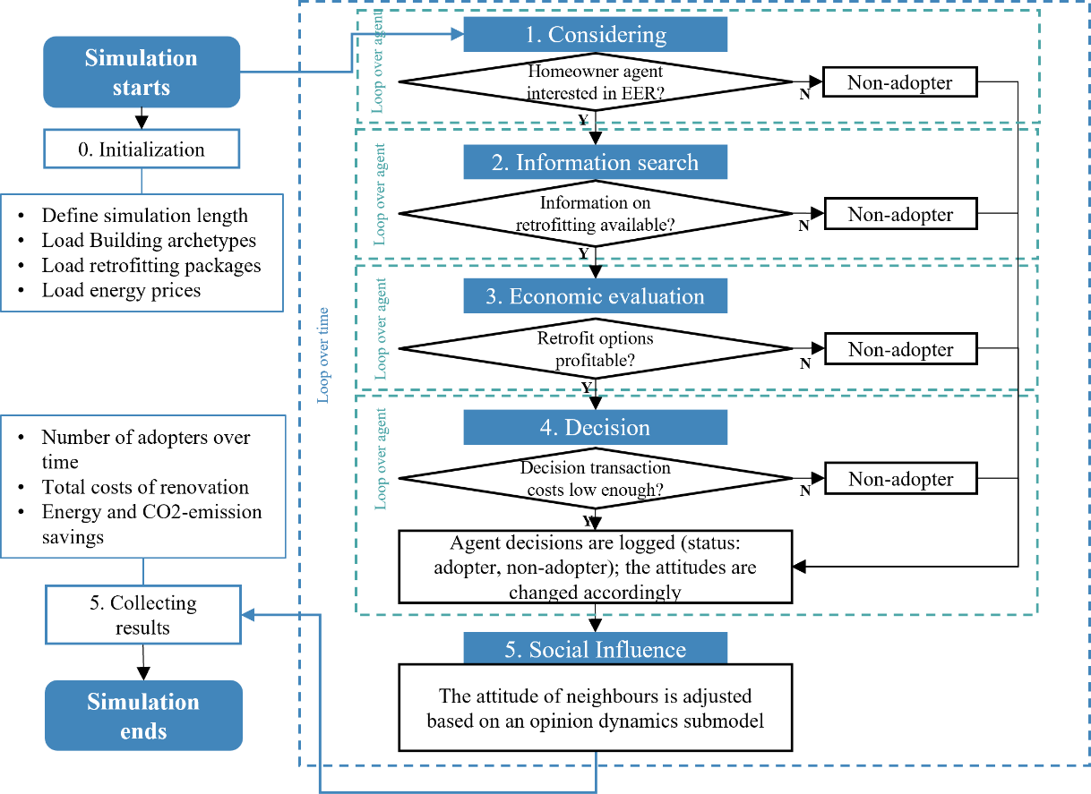
Figure 1. The flowchart of the agent-based simulation of retrofit uptake

Conclusions
One of the most inclusive and social approaches that is being tested currently in the Netherlands is neighbourhood heat transition approach, whereby neighbourhood-level solutions to gas-free heating are planned and implemented [14]. The model presented in this work is an exploratory tool that could potentially be used to test the effect of various neighbourhood-level measures to increase the uptake of retrofitting. Preliminary results indicate that the explicit modelling of barriers and agents’ heterogeneity leads to different outcomes compared to purely economic modelling. Depending on the specific conditions, mix of agents and economic conditions, certain policy measures such as one-stop shops, reducing transaction costs or neighbourhood renovation campaigns, affecting awareness and attitude of people may have a significant impact. These policy conclusions will be further elaborated in the full paper, based on the final model results.

References
[1] Buildings Performance Institute Europe (BPIE). Report on the evolution of the European regulatory framework for buildings efficiency. 2022.
[2] Wilson C, Crane L, Chryssochoidis G. Why do homeowners renovate energy efficiently? Contrasting perspectives and implications for policy. Energy Res Soc Sci 2015;7:12–22. https://doi.org/10.1016/j.erss.2015.03.002.
[3] Fowlie BM, Greenstone M, Wolfram C. Are the Non-Monetary Costs of Energy Efficiency Investments Large ? Understanding Low Take-up of a Free Energy Efficiency Program † 2015;105:201–4.
[4] Ebrahimigharehbaghi S, Qian QK, Meijer FM, Visscher HJ. Transaction costs as a barrier in the renovation decision-making process: A study of homeowners in the Netherlands. Energy Build 2020;215:109849. https://doi.org/10.1016/J.ENBUILD.2020.109849.
[5] Lundmark R. Time-adjusted transaction costs for energy renovations for single-family house-owners. Energy Econ 2022;114:106327. https://doi.org/10.1016/j.eneco.2022.106327.
[6] Alavirad S, Mohammadi S, Hoes PJ, Xu L, Hensen JLM. Future-Proof Energy-Retrofit strategy for an existing Dutch neighbourhood. Energy Build 2022;260:111914. https://doi.org/10.1016/J.ENBUILD.2022.111914.
[7] Rose J, Thomsen KE, Domingo-Irigoyen S, Bolliger R, Venus D, Konstantinou T, et al. Building renovation at district level – Lessons learned from international case studies. Sustain Cities Soc 2021;72. https://doi.org/10.1016/j.scs.2021.103037.
[8] Weidlich A, Veit D. A critical survey of agent-based wholesale electricity market models. Energy Econ 2008;30:1728–59. https://doi.org/10.1016/j.eneco.2008.01.003.
[9] Kiesling E, Günther M, Stummer C, Wakolbinger LM. Agent-based simulation of innovation diffusion: A review. Cent Eur J Oper Res 2012;20:183–230. https://doi.org/10.1007/s10100-011-0210-y.
[10] Hansen P, Liu X, Morrison GM. Agent-based modelling and socio-technical energy transitions: A systematic literature review. Energy Res Soc Sci 2019;49:41–52. https://doi.org/10.1016/j.erss.2018.10.021.
[11] Akhatova A, Kranzl L, Schipfer F, Heendeniya CB. Agent-based modelling of urban and district energy systems – A systematic literature review. 2021.
[12] Despretz H, Hanratty M. Use of Building Typologies for Energy Performance Assessment of National Building Stocks . Existent Experiences in European Countries and Common Approach. 2012.
[13] Deffuant G, Neau D, Amblard F, Weisbuch G. Mixing beliefs among interacting agents. Adv Complex Syst 2000;03:87–98. https://doi.org/10.1142/s0219525900000078.
[14] Information about the heat transition in the Netherlands | Expertise Centrum Warmte n.d. https://expertisecentrumwarmte.nl/english/default.aspx (accessed March 31, 2023).

