HOW EFFECTIVE ARE CARBON PRICES FOR REDUCING EMISSIONS? EMPIRICAL EVIDENCE FROM AUSTRALIA AND SLOVENIA

Daniel Kraynak, University of Maryland, College Park, MD, USA (dkraynak@umd.edu)
Govinda R. Timilsina, World Bank, Washington, DC, USA (gtimilsina@worldbank.org)
Anna Alberini, University of Maryland, College Park, MD, USA (aalberin@umd.edu)

Overview: Economic theory suggests that carbon pricing is an economically efficient policy instrument to mitigate climate change (Nordhaus, 1977; Aldy et al., 2010, Timilsina, 2022). Existing empirical studies, however, report mixed findings about the effectiveness of carbon pricing. Some studies such as Andersson (2019), Metcalf (2019), Murray and Maniloff (2015) find significant reductions of emissions due to carbon pricing whereas studies such as Shmelev and Speck (2018), Wakabayashi and Kimura (2018), Pretis (2020) do not find significant emission reduction. Inconclusive empirical evidence of emission reduction due to carbon pricing could discourage its implementation to help achieve climate change mitigation pledges under the Paris Climate Agreement by 2030 and net zero emission targets in the long run. More studies are, therefore, needed to generate new empirical evidence. There are many reasons behind the inconclusive literature on the effectiveness of carbon pricing including methodology used, data quality, measurement errors. There are also real-world issues with carbon pricing policies that may limit their effectiveness. This study investigates the emission reduction effect of carbon taxes implemented where the situation was not favorable for the success of a carbon tax. Specifically, we analyze the impacts of a carbon tax implemented in Australia, where it did not last long due to political reasons, and also in Slovenia where the carbon tax had a limited coverage. The findings are quite different between these two cases.

Methodology and Data: The study employs the synthetic control technique and extensions popularized in Abadie and Gardazebal (2003). Recent developments in synthetic control and related estimation techniques have the advantage of minimal data requirements while providing a disciplined and transparent approach for the analysis of policies with aggregate data. Moreover, the extended synthetic control and related techniques are more capable than the traditional ones (Abadie, 2021), and they have desirable properties for the estimation of causal effects in many applications. We also employ the demeaned synthetic control estimator proposed by Doudchenko and Imbens (2016) for Australia because of its high emission-intensive economy. We use annual country-level panel data over the period 1980-2018 in the case of Australia. Data for Slovenia are for period 1991-2004, prior to its inclusion in the European Union. The control groups are developed to replicate the pre-existing trend in emissions prior to implementation of a carbon tax. Series of sensitivities are conducted in the formation of the synthetic group. As pre-period characteristics, variables such as emissions shares from different sectors, GDP per capita, population, and energy consumption by fuel type (coal, natural gas, and petroleum products) that provide a good fit, are considered while formulating the synthetic group.

Results: The key results of the study can be visualized in Figure 1. The left panel of the figure replicates the path of Australia’s emissions per capita along with the per capita emissions of synthetic counterparts. Until the announcement of a substantial carbon tax in 2011 in Australia, the movements of emission trends are very close between Australia and the synthetic countries. But, with the carbon tax in 2011, Australia’s emissions path deviates from its synthetic counterpart. As the figure illustrates, the emission trend in Australia was declining as long as carbon tax was in place (2011 - 2014 period), the trend starts to flatten (i.e., no more declining) when the carbon tax was repealed in 2014. The size of annual environmental impact (i.e., annual reduction of per capita CO₂ emission over the period when carbon tax was in place) ranges from 6.5% to 8.5% below Australia’s 2010 level, which is relatively high for the level of carbon tax in place (AU$23/tCO₂, around US$20/tCO₂). We find the result robust under series of sensitivity analysis including permutation tests and time-placebos. The result suggests that the carbon tax in Australia worked as it was anticipated. Unfortunately, the policy did not last long due to political reasons.

The result from Slovenia case is different (right panel in Figure 1). Prior to the carbon tax introduced in 1996, the emission path of Slovenia closely follows the emission path synthetic countries. After the introduction of carbon tax, the path of CO₂ emission does not decline consistently, instead it takes a cyclic trend. Although it dropped in 2000 when tax rate was raised, it started to increase again despite maintaining the new tax level. While the analysis benefits from a robust donor pool of European countries for synthetic group, the finding does not indicate the carbon tax produced an anticipated reduction of CO₂ emissions. A reason could be that the carbon tax was targeted to the transport sector where fuel demand is inelastic. The electricity sector, one of the main sources of CO₂ emissions in many countries, including Australia, was relatively low-CO₂ intensive in Slovenia due to nuclear energy’s dominance in its power generation during the study period.

Figure 1. Impacts of CO₂ emissions due to carbon tax in Australia and Slovenia
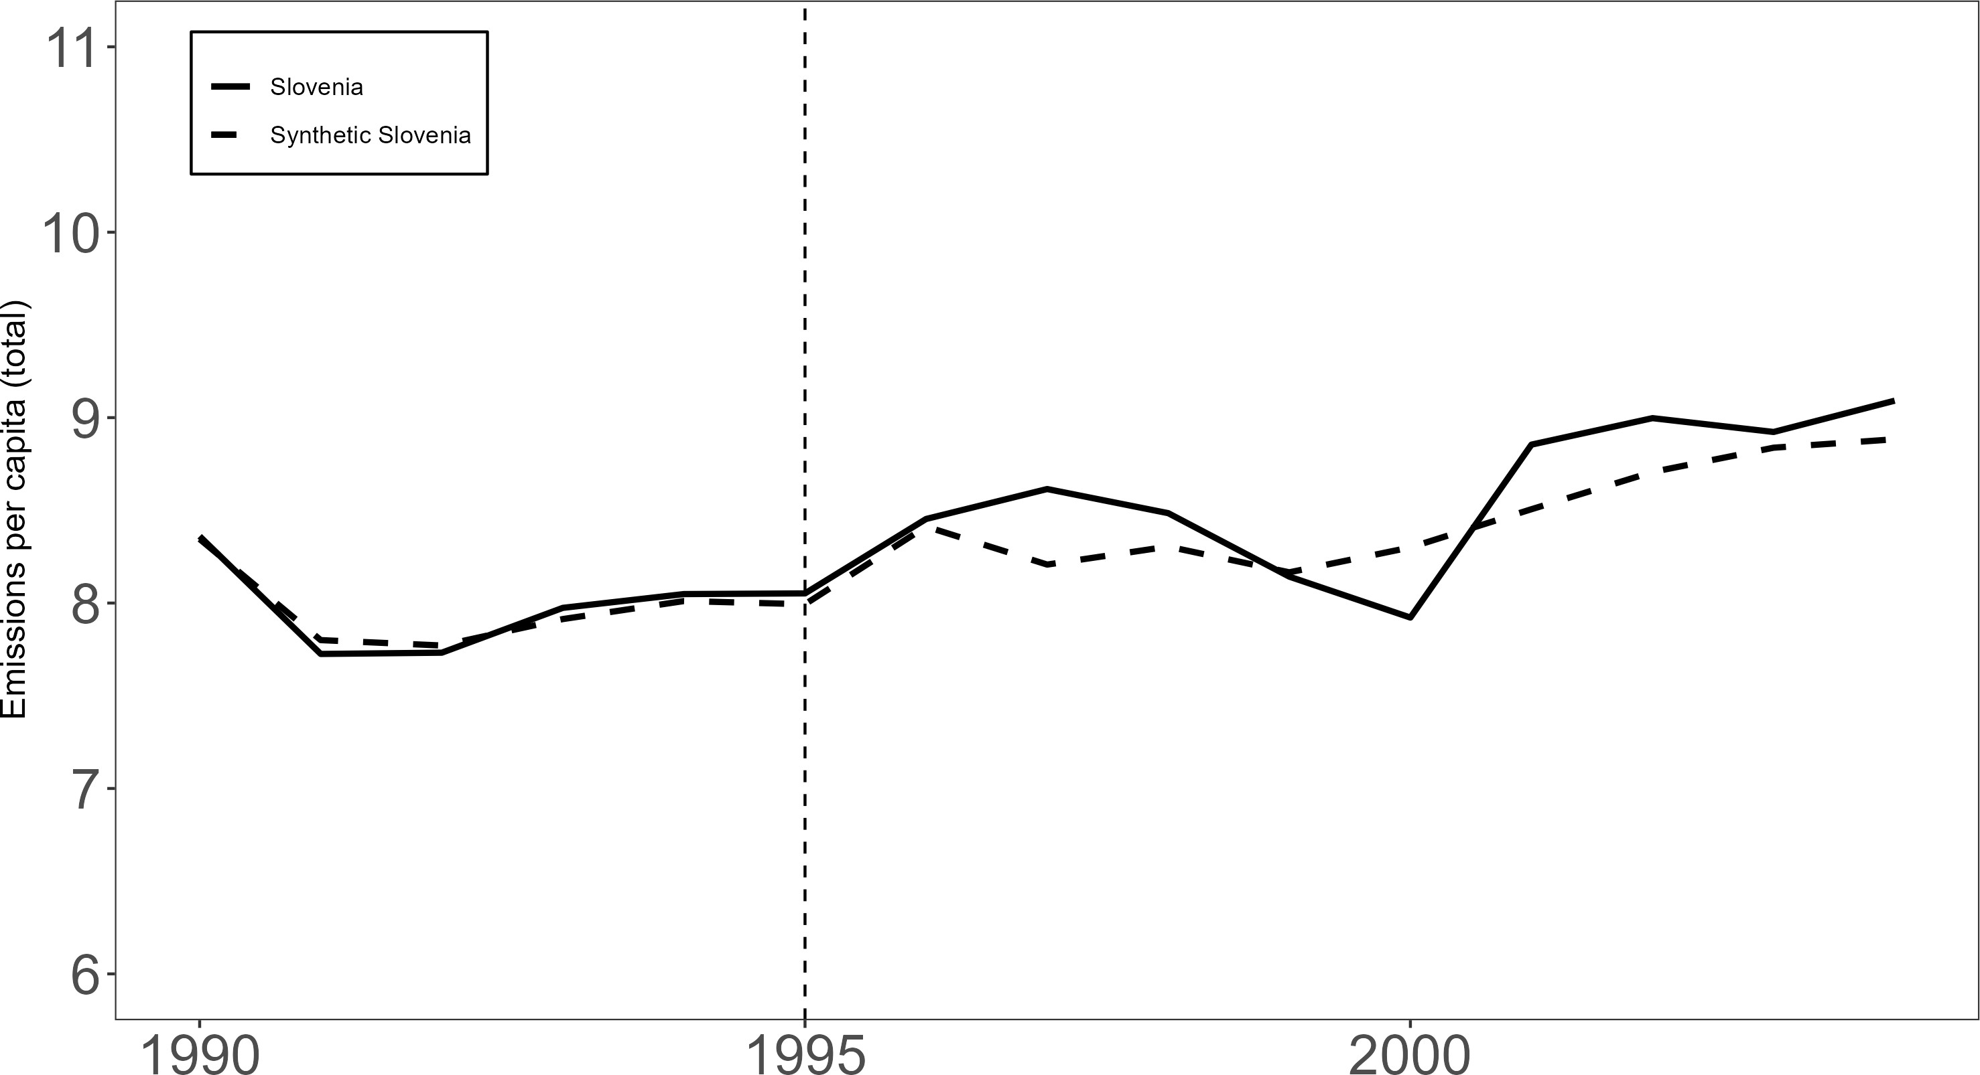
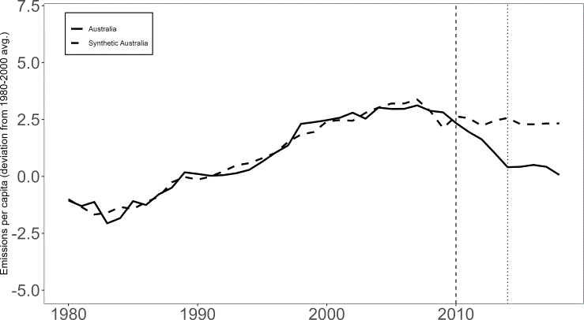

Australia Slovenia

Conclusions: Using synthetic control, this study examines the impacts of carbon pricing in Australia and Slovenia. In the case of Australia, our analysis suggests that Australia’s tax had a substantial impact on total CO₂ emissions despite the fact that the tax was repealed within four years of its implementation. On the other hand, our analysis of the Slovenian tax suggests no real impact on total emissions at the national level. The results imply that effectiveness of a carbon tax can be influenced by several factors including emission-intensiveness of an economy, tax rate and implementation environment. Thus, results from a country cannot be generalized to others.

References
Abadie A (2021). Using synthetic controls: Feasibility, data requirements, and methodological aspects. Journal of Economic Literature, 59(2):391-425.
Abadie A, Gardeazabal J. (2003). The economic costs of conflict: A case study of the Basque Country. American Economic Review, 93(1):113-132.
Aldy JE, Krupnick AJ, Newell RG, Parry IWH, Pizer WA(2010). Designing climate mitigation policy. Journal of Economic Literature, 48 (4): 903-934.
Andersson JJ (2019). Carbon Taxes and CO₂ Emissions: Sweden as a Case Study. American Economic Journal: Economic Policy, Vol. 11(4): 1–30.
Doudchenko N, Imbens GW (2016). Balancing, regression, difference-in-differences and synthetic control methods: A synthesis. Paper No. W22791. National Bureau of Economic Research.
Metcalf G (2019). On the economics of a carbon tax for the United States Brookings Papers on Economic Activity, pp 1–60 (https://www.brookings.edu/wp-content/uploads/2019/03/On-the-Economics-of-a-Carbon-Tax-for-the-United-States.pdf)
Murray BC and Maniloff PT (2015). Why have greenhouse emissions in RGGI states declined? An econometric attribution to economic, energy market, and policy factors. Energy Econmics, 51: 581–589.
Nordhaus WD (1977). Economic growth and climate: The carbon dioxide problem. The American Economic Review, 67(1):341-346.
Pretis F (2020). Does a Carbon Tax Reduce CO2 Emissions? Evidence From British Columbia SSRN Journal (https://doi.org/10.2139/ssrn.3329512).
Shmelev SE and Speck SU (2018). Green fiscal reform in Sweden: econometric assessment of the carbon and energy taxation scheme. Renewable and Sustainable Energy Reviews, 90: 969–981.
Timilsina GR (2022). Carbon Taxes. Journal of Economic Literature, 60(4):1456–1502.
Wakabayashi M and Kimura O (2018). The impact of the Tokyo Metropolitan Emissions Trading Scheme on reducing greenhouse gas emissions: findings from a facility-based study. Climate Policy, 18: 1028.

