THE EVOLVING COMPETITIVE LANDSCAPE FOR ENERGY
STORAGE TECHNOLOGIES OVER THE COMING DECADE
Iain Staffell, Imperial College London, i.staffell@imperial.ac.uk
Oliver Schmidt, Storage Lab, Berlin, Germany.
Overview
Energy systems are seeing rapid and profound transformations. Electric vehicles are becoming mainstream, and millions of wind and solar farms are replacing conventional power plants, creating fundamental challenges for the economics and security of electricity supply. Energy storage could resolve these and drive cost-effective deep decarbonization. The storage industry is therefore projected to grow to hundreds of times its current size in the coming decades. However, assessing the economic case for energy storage and the future roles it will play is complicated by rapidly falling investment costs, the wide range of technologies, and the vast array of use cases.
Methods
This talk will introduce a holistic method to assess the costs of energy storage technologies for stationary applications. It will cover future prices based on historic cost-reduction trends, deriving experience curves for several energy storage technologies. It will translate these into application-specific lifetime costs, using the metric of levelised cost of storage (analogous to the levelised cost of energy widely used for power generation costs). The lifetime cost of storage energy is then projected into the future by extrapolating experience curves for each technology, and assessing them across the full spectrum of potential applications – varying discharge duration from sub-hourly to inter-seasonal and the number of cycles per year from once per year to multiple times per day. This reveals which energy storage technologies are likely to provide the lowest cost for all possible applications, and how this mix of technologies will evolve in the coming decade.
Results
Currently, pumped hydro is the most economical technology for meeting most energy storage applications (indicated by circles in panel a below). Lithium ion is the lowest cost for a small number of low-duration applications (black start, frequency response and demand charge reduction). Over the coming decade, lithium ion is expected to become the lowest-cost technology for many more applications, primarily taking territory from pumped hydro, but also reducing the viable space for compressed air storage. This is due to the high rate of cost reductions (experience rate) for lithium ion compared to other technologies.
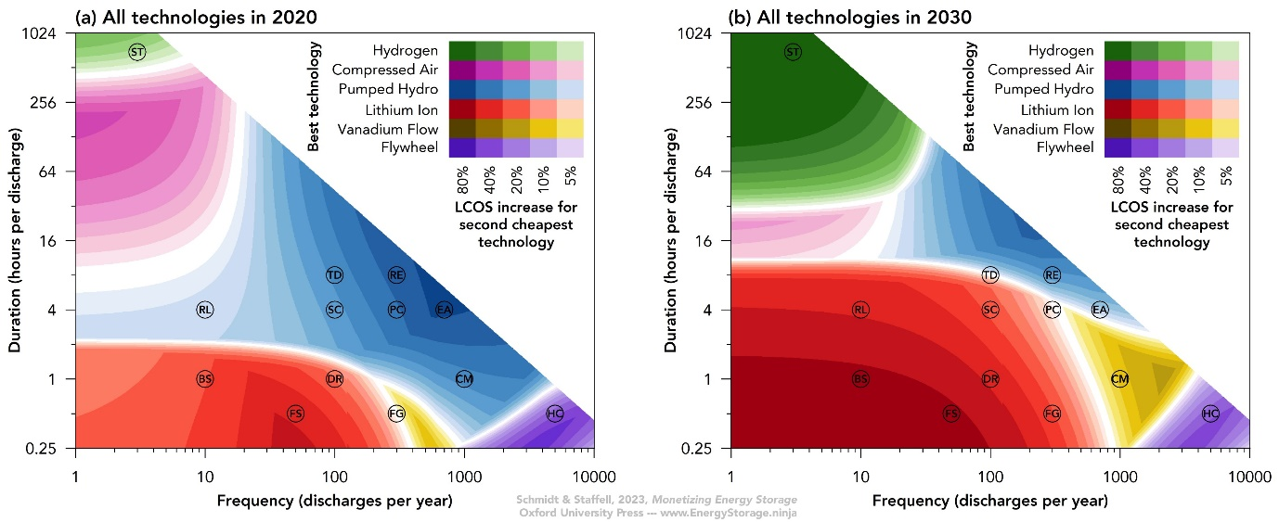
Conclusions
Lifetime cost metrics provide a fair basis for comparing the merits of different energy storage technologies, accounting for all relevant technical and economic parameters relating to both the technology and its intended application. As well as running through the implications of these findings, this talk introduces attendees to the www.energystorage.ninja website, which enables custom analysis current and future costs.

