**MULTICRITERIA ANALYSIS FOR ENERGY STORAGE VALUATION: ECONOMIC SIMULATION OF ENERGY SCENARIOS IN ISLANDS GRIDS**

Antoine DEBILLE, Nantes University, LEMNA, France, +33 6 83 15 32 92, [antoine.debille@gmail.com](mailto:antoine.debille@gmail.com)

Rodica LOISEL, Université de Nantes, LEMNA, [rodica.loisel@univ-nantes.fr](mailto:rodica.loisel@univ-nantes.fr)

## Overview

This study investigates the system benefits of the integration of energy storage technology to support variable renewables integration. The case study is the French island of Guadeloupe, where power specificities are the high share of fossil fuels, i.e. diesel and coal, and the significant seasonal variability of the load. An optimisation model is built to test energy scenarios targeting 100% renewables on the island such as to minimize the waste of energy, i.e. the power curtailed, subject to hourly supply-demand balance. Short term and long term duration storage technology are compared through seven sizing scenarios involving underwater isothermal CAES and lithium-ion batteries. A multicriteria analysis is done to evaluate which sizing scenario best fits policies and targets in terms of renewables’ integration support, curtailment avoiding, and utilization factors of storage. This frame of analysis re-evaluates the method of energy storage valuation into a multidimensional systemic approach where storage is considered through environmental impacts, technical requirement and economic efficiency.

## Methods

The analysis is separated in two steps, first an optimisation model is built to minimize the waste of energy on the island. Then, the optimisation results are studied through a multicriteria analysis. The optimisation model is used with seven storage sizing scenarios, based on given baseline energy mix scenario for 2030, where energy storage technologies are allocated between lithium-ion batteries and underwater I-CAES storage such as every combination of storage technologies offers the same capacity (550 MWh of storage capacity; Chotard et al., 2019). The model uses linear programming implemented in Python using Pyomo package with the Glpk solver. The model is dynamic with 8,760 time slices. The results are the flow of the electricity generated by each technology and the flow of charged and discharged electricity by both storage technologies, on an hourly basis. In order to mimic the dispatch of electricity generation on the island of Guadeloupe the model minimises the annual system flow of produced and stored energy. The power market equilibrium is set every hour, and the order of entry for each generating technology is constraint to follow the political target of the island which ensures a minimum of 70% renewable energy in the electric mix (Direction de l’environnement, de l’aménagement et du logement de la Guadeloupe, 2017).

***Equation 1****. Objective function of the optimisation model*

$$Minimize f\left(w\right)= \sum_{t=1}^{T}{\left[\left(\sum_{p}{Q_{t}^{p}*ω^{p}}+\sum_{s}{\left(Q_{t}^{s}*ω^{s}+{Q^{'}}_{t}^{s}*ω^{'s}\right)}\right)+\left|{∂^{'}}_{t}\right|*ω^{∂}\right]}$$

$Q_{t}^{p}$: volume of produced electricity by the power plant *p* in time *t*

$Q_{t}^{s}$: volume of discharged electricity by the storage plant *s* in time *t*

${Q'}_{t}^{s}$: volume of charged electricity by the storage plant *s* in time *t*

${∂'}_{t}$: equilibrium variable (difference between supply and demand of electricity)

$ω$: merit-order related coefficient applied to each variable

***Table 1.*** *Storage sizing scenarios*



The optimisation results are analysed using a multicriteria analysis method called Analytic Hierarchy Process (AHP). This method, developed by Saaty in 1980, is a tool used to hierarchically structure a decision problem. This method helps to expose the relationship between factors used in the decision making process through a scoring procedure (Saaty, 1990). In this assessment the factors are represented by the optimisation outputs, organized under three dimensions: environmental impacts, technical outputs and economic parameters. Each output is assigned to a numerical weight in regard to public policies and targets in terms of renewables’ integration support. Storage sizing scenarios are then ranked according to the weight distribution. The impacts of storage technology and size choice are then analysed by looking individually at each dimension.

## Results

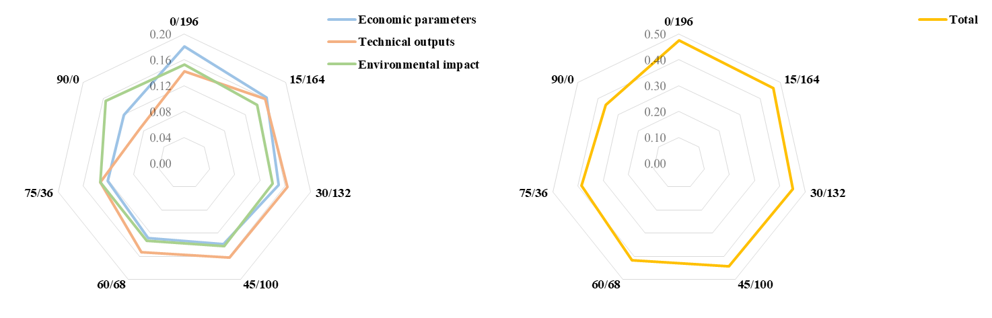

***Fig 1.*** *Analytic hierarchy process results; scores per dimension and total for every scenarios*

After the analysis of the optimisation results, the best scenarios according to the AHP method would be the one where only batteries are installed on the island. On the opposite side, the scenario where only I-CAES is installed has the lowest score. By looking closely at the three studied dimensions, it appears that the scenario where only I-CAES are installed is the best in terms of environmental impacts, in the matter of CO2 emissions and volumes of electricity injected to the grid from renewable power plants, despite their lowest overall score. Regarding the technical dimension, batteries offer a better performance (based on volume of curtailed energy, energy loss related to round trip efficiency, capacity factors and usage factors), which translates into a power to energy ratio best fitted for Guadeloupe energy system peculiarity, where the I-CAES power to energy sizing is not optimal.

## Conclusions

We conclude that the incorporation of AHP method in the assessment of prospective electricity mix allows a better identification of the drivers which are key to the selection of a suitable mix. By virtue of public policies, detailing the analysis under three dimensions enhanced the results readability and brought to light scenarios weaknesses and strengths, which can be used to complement the accuracy of the political target in decision making process.

By means of optimisation modelling, the study shows that a significant energy curtailed saving required large installed capacities of energy storage. Concerning storage technology, the difference between peak loads and renewable availability in islands territories is such as it requires high power delivery as much as long term duration discharge. The power to energy ratio has to be thought in advance to avoid the installation of an oversized storage plant, according to local peculiarity such as frequency of shut down and start up due to weather hazard, or intermittency of energy inflows (e.g. shut down in Guadeloupe island lead to energy losses up to 15% of gross consumption) (OREC Guadeloupe, 2019).

## References

Chotard, D., Mairet, N., Lefillatre, T., Babonneau, F., Haurie, A., & Biscaglia, S. (2019). *Towards energy autonomy in non-interconnected areas by 2030 - Final study report for Guadeloupe*. ADEME. *In French.*

Direction de l’environnement, de l’aménagement et du logement de la Guadeloupe. (2017). *Multiannual Energy Plan (MEP) 2016-2018/2019-2023 of Guadeloupe*. https://www.guadeloupe.developpement-durable.gouv.fr/mise-a-disposition-du-public-de-la-programmation-a1866.html. *In French.*

OREC Guadeloupe. (2019). *Guadeloupe Energy Balance 2019*. *In French.*

Saaty, T. L. (1990). *How to make a decision : The Analytic Hierarchy Process*. European journal of Operational Research 48 (1990) 9-26.